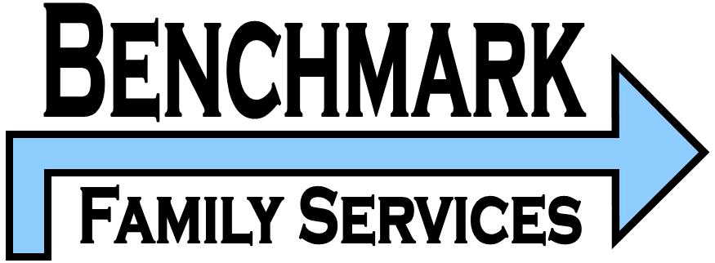
CLOTHING AND BELONGINGS INVENTORY FORM

Client Name:

Date Completed: Initial: Follow-up: Discharge:

Essential Items: | # of Items  Child Owns | # of Items  Requested | Miscellaneous Items of Child: | # of Items Child Owns | Additional Description (ex: condition of item, etc)
Underwear |  |  | Personal Stereo
Bras |  |  | Head Phones
Slips |  |  | Pillow(s)
Socks |  |  | Blanket(s)
Pajamas |  |  | Toys:
Robe(s) |  |  | Action Figures
Short Sleeve Shirts |  |  | Balls
Tank Tops |  |  | Other-
T-Shirts |  |  | Other-
Long Sleeve Shirts |  |  | Other-
Sweatshirts |  |  | Other-
Sweaters |  |  | Other-
Shorts
Slacks
Jeans
Capris
Lightweight Jacket
Winter Jacket/ Coat
Skirts
Dresses
Shoes
Sandals
Boots
Hats
Gloves
Belt(s)
Luggage, tote, duffel bag, etc.
Other:
Other:
Other:

Therapeutic Support Specialist Signature: Date:

Foster Parent Signature: Date:

